CGT / CNIT 141 Lab 2

I. Set-up of folders and empty files.

- Create a new folder and call it Lab2. Make sure there are no spaces in the name (No: Lab 2 ; Yes: Lab2)
- Open up the Lab2 Folder and create a new text file inside of it. Call it index.html
- Create a new folder inside of the Lab2 folder and call it css
- Create a new folder inside of the Lab2 folder and call it images
- Open the CSS folder and create a new text file called master.css
- Copy the image 141_Lab_2_banner.png from the zip file that you downloaded for this lab (141_Lab_2.zip) to your images folder
If you have done everything properly, you should have a set of folders and files as shown below:

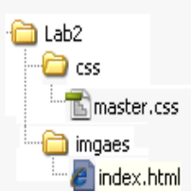

II. Set up index.html as an xHTML 1.0 document using the transitional DTD.
- Open index.html and type in the following.

<?xml version="1.0" encoding="UTF-8"?>
<!DOCTYPE html PUBLIC "-//W3C//DTD XHTML 1.0 Transitional//EN"
"http://www.w3.org/TR/xhtml1/DTD/xhtml1-transitional.dtd">
<html>
<head>
<meta http-equiv="Content-type" content="text/html; charset=UTF-8" />
<title>Laboratory 2</title>
<style type="text/css" media="all">@import "css/master.css";</style>
</head>
<body>
<div id="page-container">

</div>
</body>
</html>

At this point, you have a blank xHTML document that will validate against the Transitional xHTML 1.0 DTD. We have also set it up to use master.css as the CSS file for this page. We also have a container (div) for the entire page
- Modify the body of your document as follows.

<body>
<div id="page-container">

<div id="header">Header</div>

<div id="sidebar">Sidebar</div>

<div id="content">Content</div>

</div>
</body>

Preview your document. You have create 3 additional containers inside of the your html page.

- Change the contents of the header div to read as shown below.

<div id="header"><img src="images/banner.png" alt="banner" /></div>

Preview your document. If all it ok, the banner.jpg image should show up in the header area.

- Change the of the content div to read as shown below.

<div id="content">
<h1>CGT 141 Learns xHTML</h1>
</div>

Preview your document. Your page should look similar to the one below. If you have installed the HTML Validate plug-in for Firefox, you should also get a green checkmark indicating that you have 0 validation errors (see the lower right corner of the image).

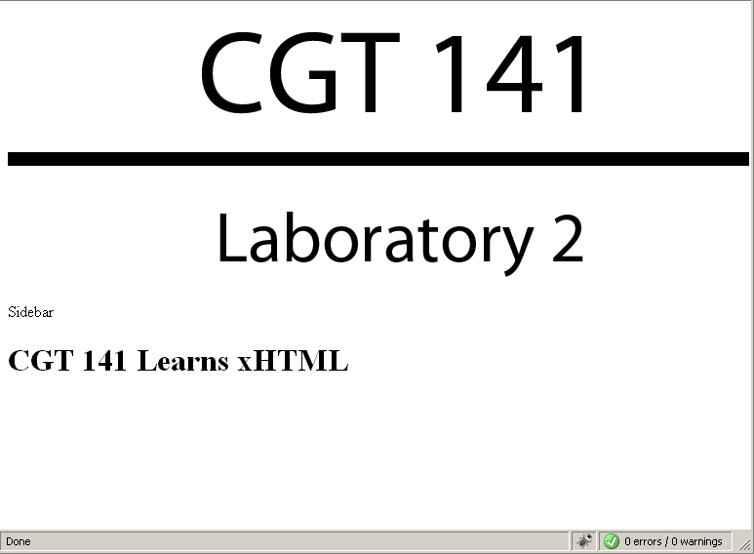

- Let’s now put 4 paragraphs of filler text into the content area.
  - Navigate to http://www.lipsum.com/ and generate 4 paragraphs of text by: (1) scrolling to the bottom of the page, (2) putting in 4 into the text box, (3) selecting the paragraphs radio button, and (4) clicking on Generat Lorem Ipsum.

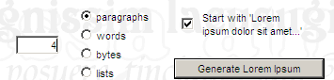
  - Select and copy the generated text from the Lorem Ipsum site.
  - Now paste the generate text into the content div as shown below. Note that your need to place an opening paragraph tag <p> before each of the paragraphs, and an closing paragraph tag </p> after each of the paragraphs.

Note: the exact text generated by Lorem Ipsum will vary. So your page will not look exactly like mine. The important thing, is that you have properly declared paragraphs with opening and closing tags.

<div id="content">
<h1>CGT 141 Learns xHTML</h1>
<p>Lorem ipsum dolor sit amet, consectetur adipiscing elit. Aliquam neque tortor, euismod viverra blandit non, scelerisque a ligula. Praesent cursus, eros vitae eleifend accumsan, est magna luctus ante, vitae gravida arcu ante sit amet nisl. Proin eu nunc lacus, et adipiscing dolor. Sed ipsum nisl, tempor ac sollicitudin sit amet, porttitor sed nisi. Donec condimentum consectetur erat laoreet varius. In elementum velit nec diam ornare rhoncus. fermentum vulputate semper. Ut eget cursus enim. Ut molestie tincidunt porta.</p>

<p>Vestibulum sed libero ut arcu iaculis pellentesque in a dolor. Sed at convallis lacus. Phasellus molestie dapibus semper. Sed pellentesque felis ut lectus pulvinar luctus. Fusce eu nunc dolor, eu viverra turpis. Aliquam sagittis lorem eget dolor bibendum ultrices. Donec at dolor lorem, ut est eget ullamcorper. Phasellus nec feugiat felis. Cum sociis natoque penatibus et magnis dis parturient montes, nascetur ridiculus mus.</p>

<p>Nunc facilisis enim velit. Proin non vestibulum felis. Nunc porta nulla sed urna aliquet mollis. Ut porttitor, urna at blandit tempor, purus dui rutrum justo, vel elementum velit purus vitae lorem. Nulla facilisi. Mauris molestie nibh. Praesent tincidunt augue ac tortor accumsan tincidunt. Vestibulum imperdiet nisl sit amet eros rutrum vel pretium arcu iaculis. Nullam quis risus non tortor molestie sodales quis ut odio. Suspendisse dapibus, dolor ut feugiat elementum, lacus eros egestas elit, ac facilisis velit magna aliquet dui. Quisque elementum nibh et risus tincidunt blandit. </p>

<p>Aenean faucibus tellus sit amet neque volutpat ultrices. Morbi vehicula ultrices ultrices. Quisque aliquam massa ut eros consequat quis vulputate fermentum. Praesent leo tellus, sagittis sit amet gravida non, pellentesque nec massa. Vestibulum ut est sed magna euismod tincidunt. Maecenas ante lorem, pretium eget sollicitudin a, auctor pulvinar justo. Cum sociis natoque penatibus et magnis dis parturient montes, nascetur ridiculus mus. Aenean ac justo at arcu bibendum tempor vel vitae leo. Donec venenatis, dolor sodales ultricies tristique, tellus orci sagittis ipsum, eu pulvinar tellus tortor in arcu. Pellentesque non nisl augue, a porta enim. Fusce nec tortor eu leo aliquam sagittis ut ut nibh</p>
</div>

If you did this correctly, your page will look similar to the next image. It should also validate properly.

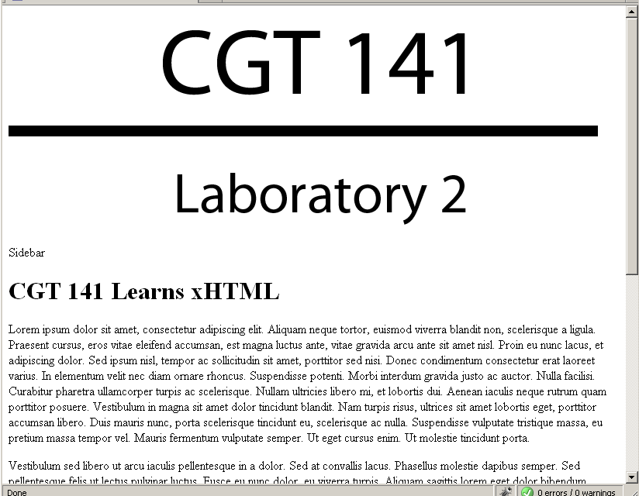

- Now let’s put 3 of stories into the sidebar. Each of the stories will have a title, which we will designate as a heading 2, and 1 paragraph of text.
  - Modify the content of the sidebar div as show below

<div id="sidebar">
<h2>Thursday are good</h2>

<h2>xHTML is easy</h2>

<h2>Sleep is good</h2>

</div>

At this point, you have heading for the stories, but no text associated with those stories. Let’s generate approximately 3 sentences (or 25 words) of lorem ipsum filler text and place into paragraphs associated with each of the stories.

  - Navigate to http://www.lipsum.com/ and generate 25 words of text by: (1) scrolling to the bottom of the page, (2) putting in 25 into the text box, (3) selecting the words radio button, and (4) clicking on Generat Lorem Ipsum.

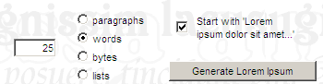
  - Select and copy the generated text from the Lorem Ipsum site.
  - Now paste the generate text into the sidebar div as shown below. Note that your need to place an opening paragraph tag <p> before each of the paragraphs, and an closing paragraph tag </p> after each of the paragraphs. You should do this after each of the heading 2 tags.

<div id="sidebar">
<h2>Thursday are good</h2>
<p>Lorem ipsum dolor sit amet, consectetur adipiscing elit. Aliquam non dui vel lorem consectetur vulputate. Aenean pharetra adipiscing luctus. Integer eu neque sed risus hendrerit.</p>
<h2>xHTML is easy</h2>
<p>Lorem ipsum dolor sit amet, consectetur adipiscing elit. Aliquam non dui vel lorem consectetur vulputate. Aenean pharetra adipiscing luctus. Integer eu neque sed risus hendrerit.</p>
<h2>Sleep is good</h2>
<p>Lorem ipsum dolor sit amet, consectetur adipiscing elit. Aliquam non dui vel lorem consectetur vulputate. Aenean pharetra adipiscing luctus. Integer eu neque sed risus hendrerit.</p>
</div>

Again note that the exact text generated by Lorem Ipsum will vary. So your page will not look exactly like mine. The important thing, is that you have properly declared paragraphs with opening and closing tags.

If you did this correctly, your page will look similar to the next image. It should also validate properly.

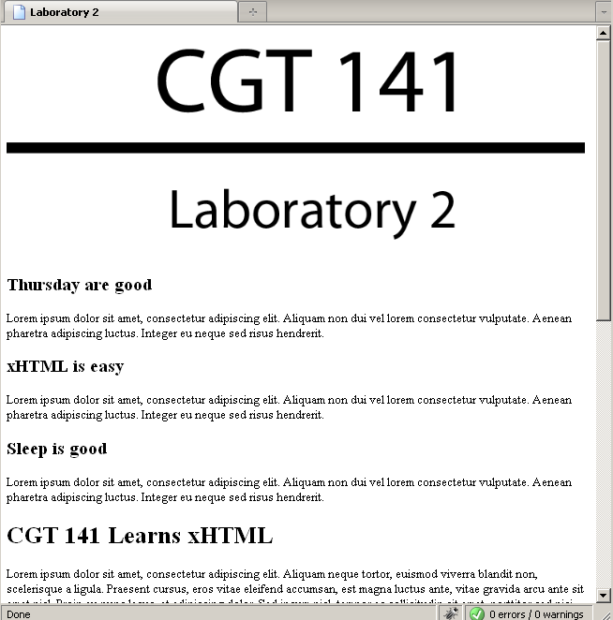
Notice that is still validates properly.

III. The structural layer is done. Now, let’s focus on making it look good
At this point, we have an xHTML document that accurately describes the structure & sementics of our document. However, it does not look very good. The size and fonts for the heading not very aesthetic pleasing. We will not fix this by modifying the css document that we associated with our xHTML document.

- Open the master.css file inside of the css folder.
- First let’s set the width for the entire page by typing:

#page-container {
width: 760px;
}

- Set the right margin for the content div to 250. First let’s set the width for the entire page by typing:

#content {
margin-right: 250;
background: white;
}

- Now, let’s get rid of the space around all of the h1, h2, and p tags by setting the margin and padding to 0

h1,h2 {
margin: 0;
padding: 0;
}

- Now set the the width for the sidebar div to 250 pixels. Also set the background to yellow (or any other color that you would like. Finally set float to right.

#sidebar {
float: right;
width: 280px;
background: yellow;
}

Setting float to right, essentially takes the entire sidebar div and places it to the of the containing div. We will learn more about using floats next week when we look at CSS closer.

If you did everything correctly, the css file should look like:

#page-container {
width: 760px;
}

#content {
margin-right: 250;
background: white;
}

h1,h2 {
margin: 0;
padding: 0;
}

#sidebar {
float: right;
width: 250px;
background: yellow;
}

And the document should look like:

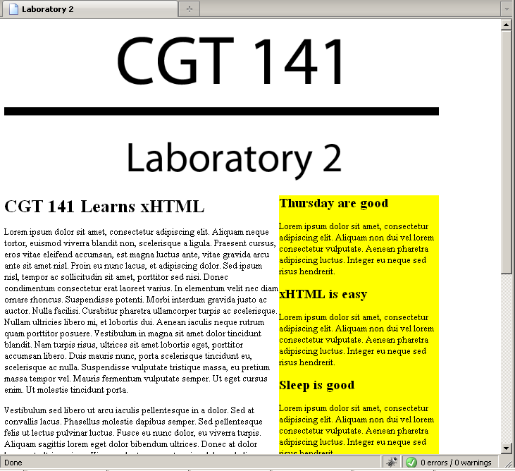

IV. Turn in your assignment
- Take a screenshot of your browser window using the Print-Screen Key
- Save the image to the root of your Lab2 folder with the name screenshot.jpg
- Copy all zip up your document
- Submit it via blackboard

Points:
12.5 pt. XHTML file
12.5 pt. CSS file
25 pt. Total

